Assignment 1:

1. Create a storage account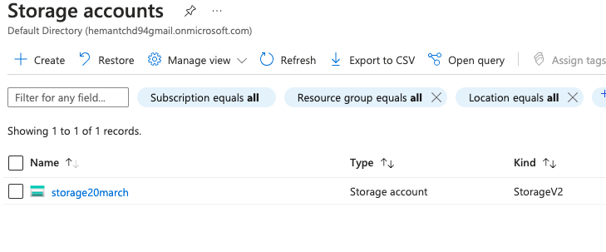

2. Connect storage explorer to this storage account

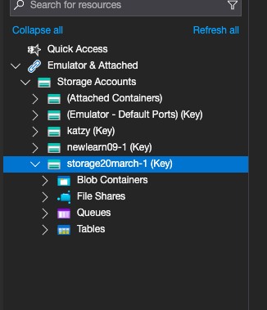

Assignment 2:

Do the following using the Storage explorer:

1. Create a file share using the Storage explorer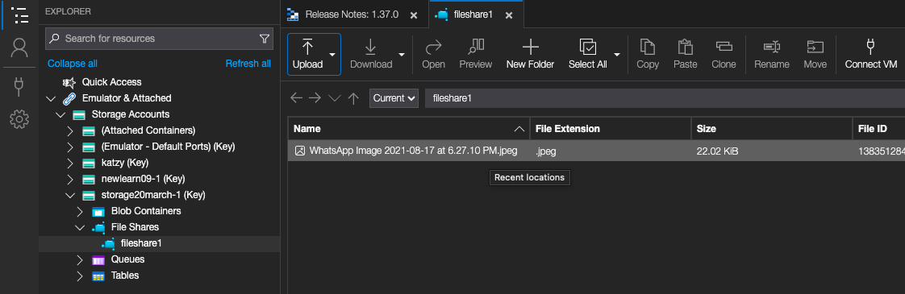

2. Upload files to the blob service 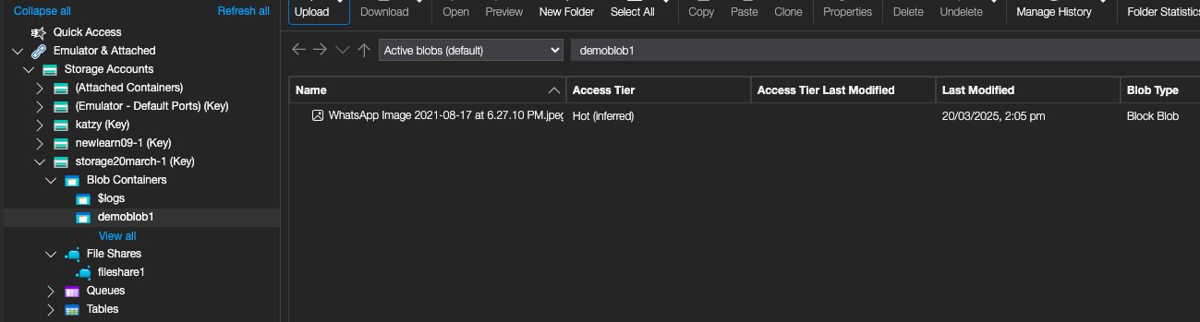

3. Create an Azure Table and insert a record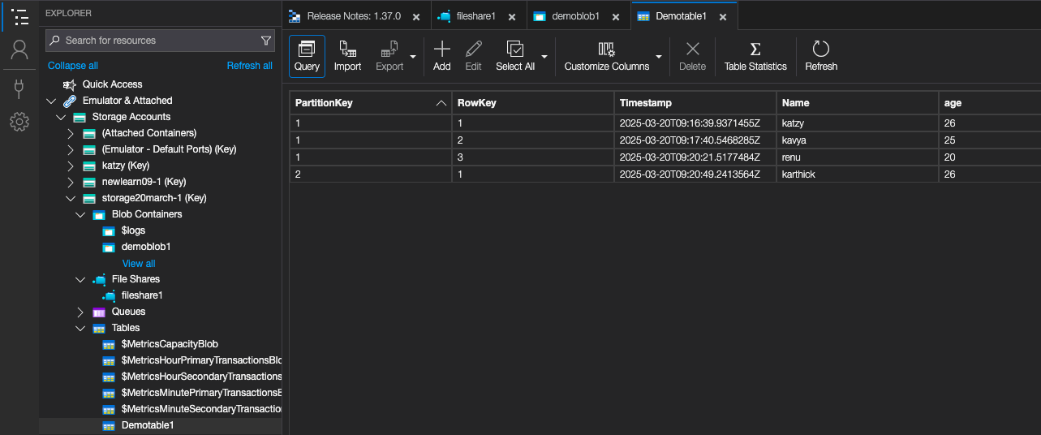

Assignment 3:

1. Create two storage accounts and create a container inside it 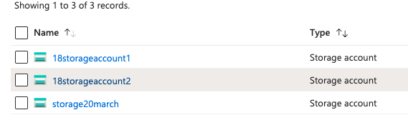

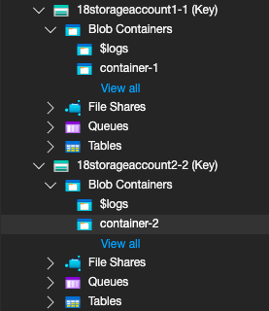

2. Upload some data to the first Blob service

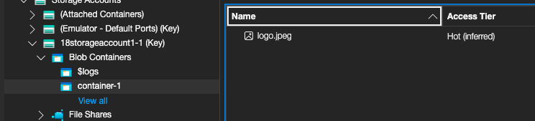

3. Using Data Factory copy data to the second storage service’s container

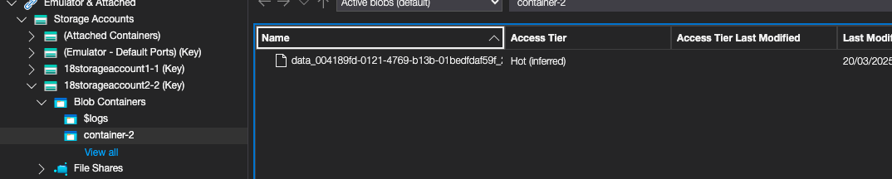

Assignment 4:

1. Use the same storage accounts from previous assignment

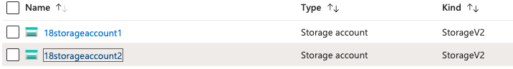

2. Use AzCopy utility to copy data from one storage container to another

